CLONAR REPOSITORIO VISUAL STUDIO CODE
Al clonar no poner @ solo poner el usuario si sale credential manager y poner las credenciales de ldap
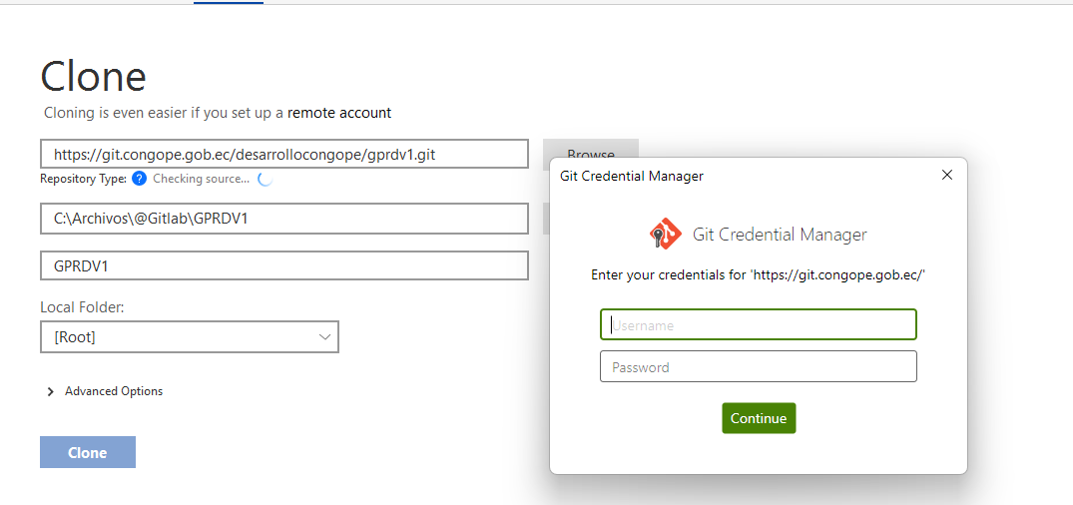

error: Pulling is not possible because you have unmerged files. hint: Fix them up in the work tree, and then use 'git add/rm <file>' hint: as appropriate to mark resolution and make a commit.
ChatGPT
This error occurs because there are conflicts in your working directory that need to be resolved before you can pull new changes. Here's a step-by-step guide on how to resolve this issue:
- Check the status of your repository:
sh
Copiar código
git status
This will show you the files that are in conflict.
- Resolve conflicts: Open the conflicted files in your text editor and resolve the conflicts. Git marks the conflicts in the files, showing the conflicting changes from both branches. The conflict markers look like this:
sh
Copiar código
<<<<<<< HEAD
// your changes
=======
// changes from the branch you are pulling
>>>>>>> branch-name
Keep the changes you want, and remove the conflict markers.
- Add the resolved files: Once you've resolved the conflicts, add the resolved files to the staging area:
sh
Copiar código
git add <file>
If you have multiple files, you can add them all with:
sh
Copiar código
git add .
- Commit the resolved changes: After adding the resolved files, commit the changes:
sh
Copiar código
git commit -m "Resolved merge conflicts"
- Pull the changes again: Now that the conflicts are resolved and committed, you can pull the changes from the remote repository:
sh
Copiar código
git pull

Example Workflow
- Check the status:
sh
Copiar código
git status
- Resolve the conflicts in the indicated files. For example, if example.txt is conflicted, open it and edit as necessary.
- Add the resolved files:
sh
Copiar código
git add example.txt
- Commit the resolution:
sh
Copiar código
git commit -m "Resolved merge conflict in example.txt"
- Pull the latest changes:
sh
Copiar código
git pull
Following these steps should resolve the conflicts and allow you to pull the latest changes from the remote repository.

NOTAS
commit de mi rama

iirme a la rama develop
git pull
me regreso a mi rama git merge
merge conflict
tortoise solve problems
iz como estaba como esta ahorita

